Basics of Digital Audio

Sound is produced by a rapid variation in the average density or pressure of air molecules above and below the current atmospheric pressure. We perceive sound as these pressure fluctuations cause our eardrums to vibrate.

When the molecules are pushed closer together it is called compression; when they are pulled apart, it is called rarefaction. The back and forth oscillation of pressure produces a sound waves.

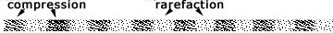

A sound wave, which is not impeded by another object, propagates (or spreads) out from the source as a sphere. The figure below illustrates the cross-section of a sound wave expanding outward from its source.

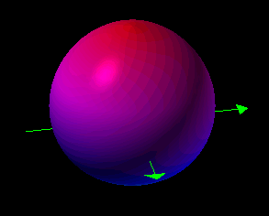

In a sound wave, the actual air molecules do not travel far, but spread their kinetic energy or force to adjacent molecules before bouncing back near their original position, much like a cue ball striking another in billiards. A sound wave is also a form of a traveling wave, in that the air molecules disturbed by the sound source are unlikely to be the ones hitting your eardrum, but transfer their energy to other neighboring molecules.

How fast does sound travel?

There is no sound in the vacuum of space because there are too few molecules to propagate a wave.

It is important to note that the speed of sound in air is determined by the conditions of the air itself (e.g. humidity, temperature, altitude). It is not dependent upon the sound’s amplitude, frequency or wavelength. To calculate the approximate speed of sound in dry air at sea level, use the following formula:

V = 331.4 + 0.6Tc
V = velocity (m/s), Tc = temperature in Celsius

Using this formula, the speed of sound at 20° Celcius (68° Fahrenheit) is:
344 meters per second (m/s)

Comparing sound in air with sound in other mediums, the speed of sound in helium at 0°C is approximately 972 meters per second (m/s), or around 3 times as fast as in air.

Sound travels even faster in liquids and solids than it does in gases because of their greater density.

Sound in 20° C water travels an average of 1482 m/s, while sound in aluminum travels at 6420 m/s. Modern navies depends heavily on being able to predict the speed of sound in varying water temperatures for their SONAR echo-location systems.

What are the characteristics of sound waves?
Some sound waves are periodic

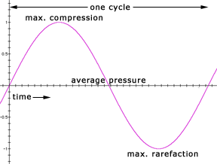

Noise is characterized as being aperiodic or having a non-repetitive pattern.
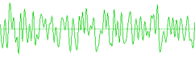
There are many different types of noise, depending primarily on the random distribution of frequencies.

What is frequency?
The number of cycles per unit of time is called the frequency. For convenience, frequency is most often measured in cycles per second (cps) or the interchangeable hertz (Hz) (60 cps = 60 Hz)

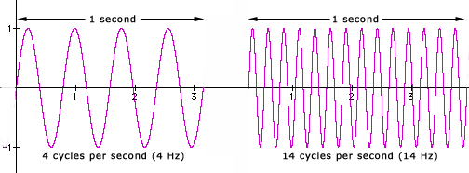

The range of human hearing in the young is approximately 20 Hz to 20 kHz—the higher number tends to decrease with age (as do many other things). It may be quite normal for a 60-year-old to hear a maximum of 16,000 Hz.

Frequency is directly related to wavelength, often represented by the Greek lambda (). The wavelength is the distance in space required to complete a full cycle of a frequency. The wavelength of a sound is the inverse of its frequency. The formula is:
wavelength ( ) = speed of sound/frequency
Example: A440 Hz (the frequency many orchestras tune to) in a dry, sea level, 68°F room would create a waveform that is ~2.5 ft. long (2.56 = 1128 (feet/sec) / 440). Be certain to measure the speed of sound and wavelength in the same units. Notice how if the speed of sound changed due to temperature, altitude, humidity or conducting medium, so too would the wavelength.

At 20°C, sound waves in the human hearing spectrum have wavelengths from 0.0172 m (0.68 inches) to 17.2 meters (56.4 feet)
One particularly interesting frequency phenomenon is the Doppler effect or Doppler shift. You've no doubt seen movies where a police siren or train whistle seems to drop in pitch as it passes the listener. In actuality, the wavelength of sound waves from a moving source is compressed ahead of the source and expanded behind the source, creating a sensation of a higher and then lower frequency than is actually being produced by the source. This is the same phenomenon used by astronomers with light wavelengths to calculate the speed and distance of a receding star. The light wavelengths as stars move away are shifted toward the red end of the spectrum, hence the term red shift.
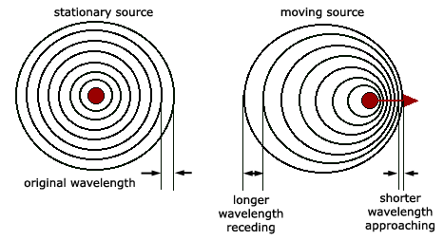
The formula for an approaching sound source is: | The formula for a receding sound source is:
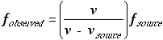 | 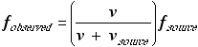
f_{observed}=frequency we hear, f_{source}=frequency of source,
v=speed of sound, v_{source}=speed of approaching or receding sound source

Example: At 20°C the speed of sound (v) is 343.7 m/s. An oboist in a convertible traveling at 29 m/s (v_{source} ) or 65 mi/hr is tuning to A440. As the convertible approaches your position, you hear 480 Hz and as the car passes and moves away, you hear 405 Hz.

What is Amplitude?

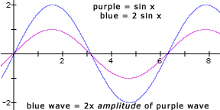

If we tried to calculate the average amplitude of a sine wave, it would unfortunately equal zero.

A more meaningful reference has been developed to measure the average amplitude of a wave over time, called the root-mean-squared or rms method. You may also see the rms measurement applied to the power output of an amplifier.

The rms value of a waveform represents a squaring the amplitude of each point of a waveform and then taking the total mathematical average.
The function of the squaring is to eliminate negative values, since all the negative values square to positive ones. This is extremely useful information for those using averaging level meters with audio equipment or software.
Example: The rms of a sine wave with a hypothetical peak-to peak value of –1 to 1 will be 0.707. This can be used to extrapolate that any rms amplitude = 0.707 x peak amplitude. Peak amplitude = 1.414 x rms amplitude.

A decibel is a measurement used to compare the ratio of intensities of two acoustic sounds (or electronic signal). The ratio (R) of two signals expressed by their power in watts (W1 and W2) is:
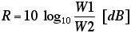
There are many different types of decibel measurements, so for the purpose of clarity, the above form, which measures power or intensity is called dBm. For the purpose of having a standardized absolute measurement of power (i.e. a comparison not to another signal, but to an industry-fixed value), the nominal reference wattage (W2) has been defined as 1 miliwatt (0.001 watt). In absolute terms, a 1-watt signal, which has 1,000 times the power of the reference wattage, will be 30 dB, computed below:
Signal to Noise Ratio (SNR)
- In any analog system, some of the voltage is what you want to measure (signal), and some of it is random fluctuations (noise).
- Ratio of the power of the two is called the signal to noise ratio (SNR). SNR is a measure of the quality of the signal.
- SNR is usually measured in decibels (dB).
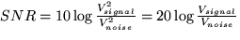

Sample Rates and Bit Size
 Sample Rate: the number of samples per second.

Nyquist's Sampling Theorem
Suppose we are sampling a sine wave.
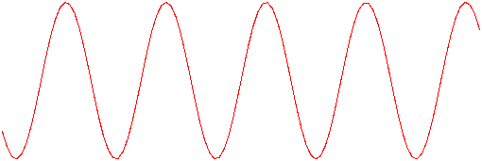
A Sine Wave
- If we sample at 1 time per cycle, we can think it's a constant
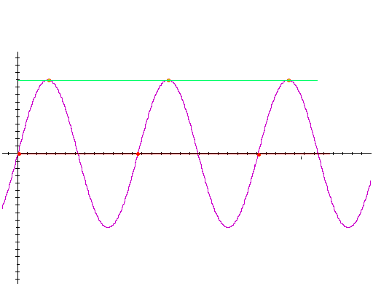
Sampling at 1 time per cycle
If we sample at 1.5 times per cycle, we can think it's a lower frequency sine wave
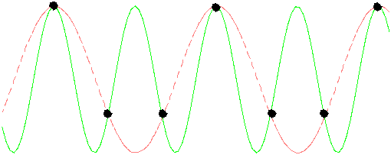
Sampling at 1.5 times per cycle
Now if we sample at twice the sample frequency, i.e Nyquist Rate, we start to make some progress. An alternative way of viewing the waveform (re)generation is to think of straight lines joining up the peaks of the samples. In this case (at these sample points) we see we get a sawtooth wave that begins to start crudely approximating a sine wave
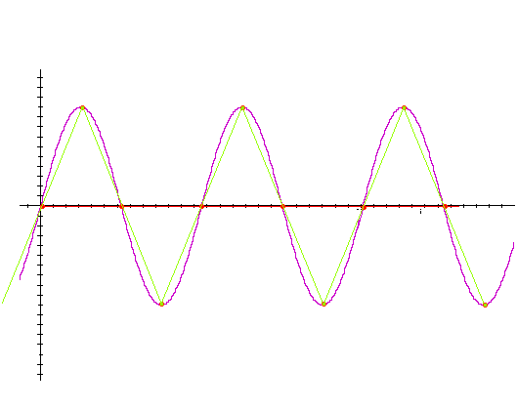
Sampling at 2 times per cycle
Nyquist rate -- For lossless digitization, the sampling rate should be at least twice the maximum frequency responses. Indeed many times more the better.
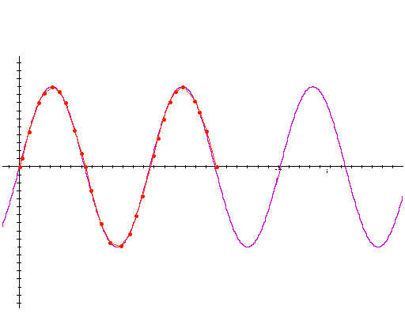
Sampling at many times per cycle
- Telephone: 8000 samples/sec.
-  CD: 44100 samples/sec
-  DVD: 48000 samples/sec

Telephony
-  8KHz sampling used 4KHz maximum frequency.
-  Human ear can hear up to ~20KHz.
- Human voice still clear when higher frequencies are lost.
- Higher frequencies convey some emotions, and are useful for identification of the speaker.
- 4KHz pretty useless for music.

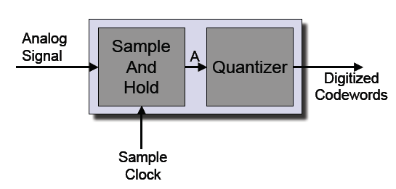

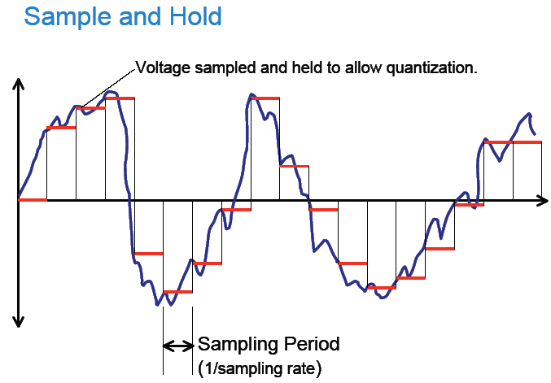

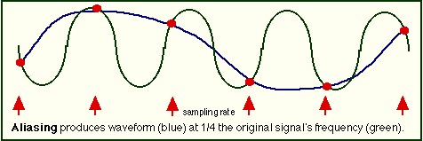

Alias frequency = abs (signal freq. - closest integer multiple of sampling freq.)
-  Folding frequency: the frequency above which aliasing occurs.
  -  Half the sampling rate.
-  Example: 7KHz input signal, 8KHz sampling: 1KHz alias
  -  Folding frequency is 4KHz.
-  Example: 17KHz input signal, 8KHz sampling: 1KHz alias
  -  17KHz - (2 * 8KHz) = 1KHz

There are two solutions to the issue of aliasing from frequencies above the Nyquist frequency in reproducing high-quality audio. The first is to band-limit the frequencies allowed to enter the system. The second is to have a higher sampling rate, thereby increasing the frequency range before aliasing occurs. In reality, both of these have been addressed by current digital audio systems.
Anti-aliasing filters are placed in front of any analog-to-digital converters to eliminate frequencies above the Nyquist frequency from ever being samples. So far, though steep, existing technology has not afforded us a true 'brick wall' filter that suddenly eliminates unwanted frequencies without having any effect on those in the 'legal' range. These is a roll off curve that attenuates frequencies closest to the cutoff.
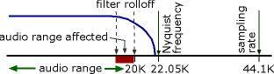

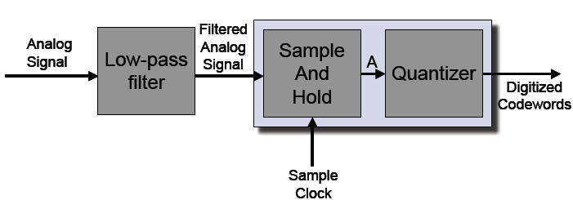

Low-pass anti-aliasing filter (cutoff at f/2) on input.
-  Signal is sampled at sampling frequency f.
-  Sampled signal is quantized into discrete values.
Quantizing, approximation errors and sample size
Samples taken are then assigned numeric values that the computer or digital circuit can use or store in a process called quantization. The number of available values is determined by the number of bits (0's and 1's) used for each sample, also called bit depth or bit resolution. Each additional bit doubles the number of values available (1-bit samples have 2 values; 2-bit samples have 4 values, etc.). When a sample is quantized, the instantaneous snapshot of its analog amplitude has to be rounded off to the nearest available digital value. This rounding-off process is called approximation. The smaller the number of bits used per sample, the greater the distances the analog values need to be rounded off to. The difference between the analog value and the digital value is called the approximation or quantizing error as shown in the illustration below:
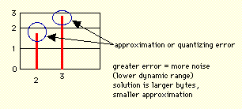
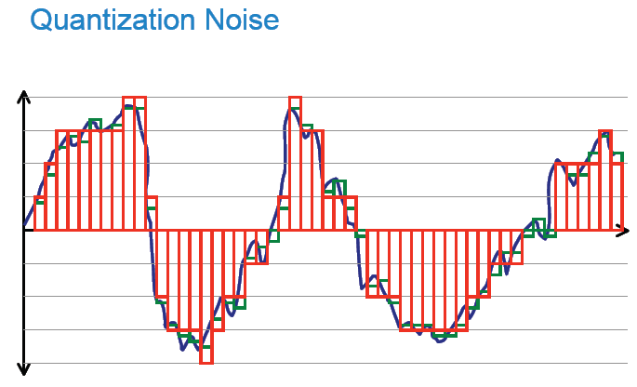

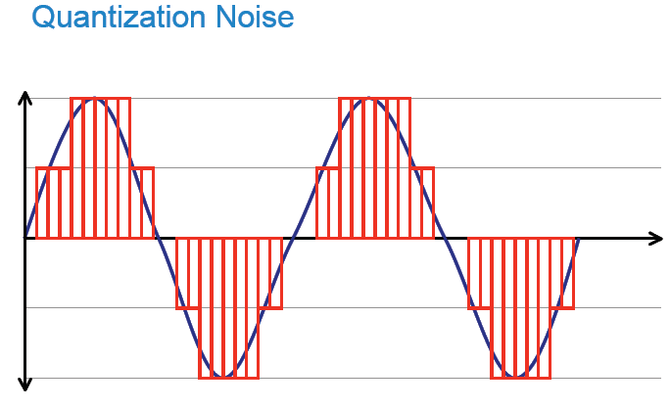
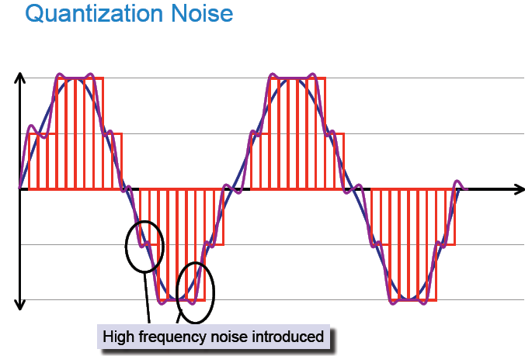
The greater the magnitude of approximation errors, the greater the level of digital or quantizing noise produced. The solution to reducing digital noise is to use larger sample sizes (greater bit depth).
How many levels?
- 8 bits (256 levels) linear encoding would probably be enough if the signal always used the full range. 8-bit has a signal-to-noise ratio of 50 dB
- CD uses 16-bit linear encoding (65536 levels). 16-Bit has a signal-to-noise ratio of 98 dB -- virtually inaudible. Therefore, 8-bit is roughly 8 times as noisy
- Pretty good match to dynamic range of human ear.
Affects Size of Data
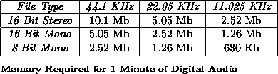
There is a trade off between Audio Quality vs. Data Rate
Some typical applications of sample bit size and sample rate are listed below:
Quality Sample Rate Bits per Mono/ Data Rate Frequency
(KHz) Sample Stereo (Uncompressed) Band
--------- ----------- -------- -------- ----------------- ------------

Telephone 8 8 Mono 8 KBytes/sec 200-3,400 Hz
AM Radio 11.025 8 Mono 11.0 KBytes/sec
FM Radio 22.050 16 Stereo 88.2 KBytes/sec
CD 44.1 16 Stereo 176.4 KBytes/sec 20-20,000 Hz
DAT 48 16 Stereo 192.0 KBytes/sec 20-20,000 Hz

Telephony
- 16 bit linear would be rather expensive for telephony.
-  8 bit linear poor quality.
-  Solution (Ears do not respond to sound in a linear fashion): use 8 bits with an “logarithmic” encoding.
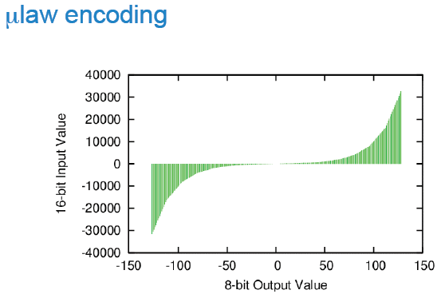
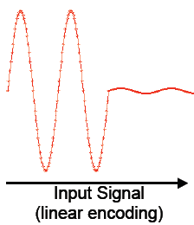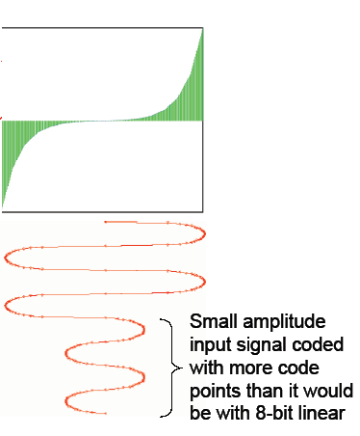

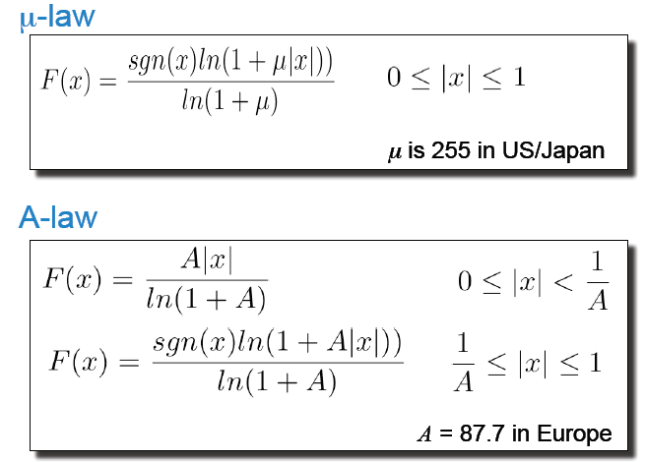
μ-law vs A-law
-  8-bit μ-law used in US for telephony
-  8-bit A-law used in Europe for telephony
- Similar, but a slightly different curve.
- Both give similar quality to 12-bit linear encoding.
- A-law used for International circuits.
-  Both are linear approximations to a log curve.
-  8000 samples/sec * 8bits per sample = 64Kb/s data rate
Higher bit-depth files can be reduced back to 16-bit for things like CD burning, often enhanced by using a process called dither, which tries to minimize the inducement of further digital noise. Dither allows higher bit depths, such as 20- and 24-bit files to be reduced to 16-bits by not doing the obvious, which would be rounding off the extra precision to the nearest 16-bit value. Instead, it combines the least significant bits below the most significant 16 with random values, then rounds up or down to the nearest 16-bit value.
For example:
Starting with a 24-bit word (each bit is either a 1 or a 0 in binary notation):
Upper 16 bits Lower 8
Original 24-bit Word MXXX XXXX XXXX XXXW YYYY YYYY
Add random number ZZZZ ZZZZ
The result of the addition of the Z's with the Y's gets carried over into the new least significant bit of the 16-bit word (LSB, letter W above), and possibly higher bits if you have to carry.

